Sayreville Middle School Musical

Attention 6th, 7th, and 8th Graders,
The Middle School P.T.O. and Music Department are proud to announce this year’s school musical!

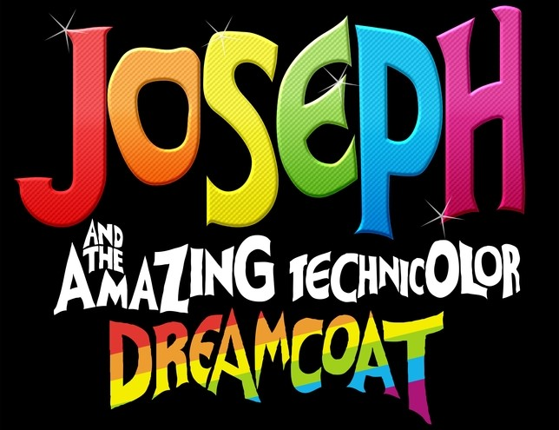

Auditions!

Wednesday, September 17th
2:30 – 5:00 PM in Room B15

Follow Joseph as he receives his multi-colored coat, is sold by his brothers as a slave,
gets thrown into prison and somehow ends up second in command to the Pharaoh himself.

If you enjoy singing, dancing, or just being on stage, this is the activity for you!

Please complete the audition form and have it signed by your parent. Forms must be turned in no later than Wednesday, 9/17 or brought with you to the audition.

